Step 1: First of all download the following mail dependency

<!-- https://mvnrepository.com/artifact/javax.mail/mail -->

<dependency>

<groupId>javax.mail</groupId>

<artifactId>mail</artifactId>

<version>1.4.7</version>

</dependency>

Step 2: Get the local IP address:

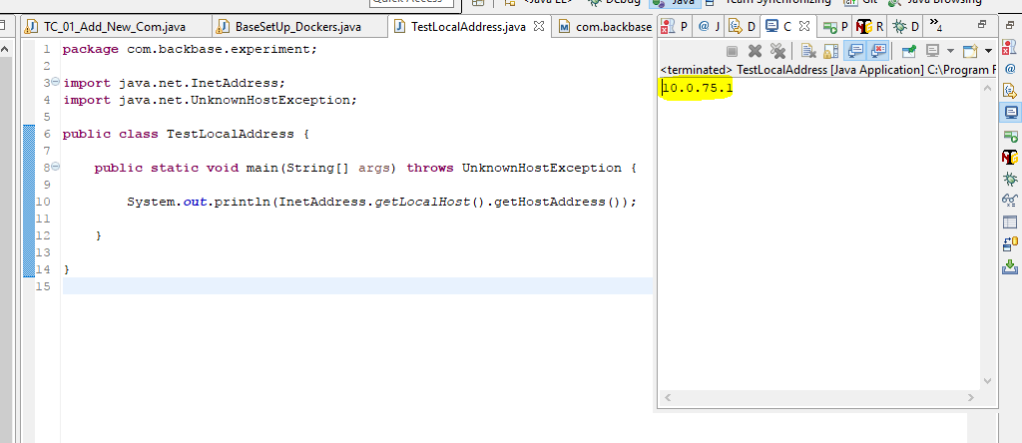

Step 3: Now open the Jenkins with above local address

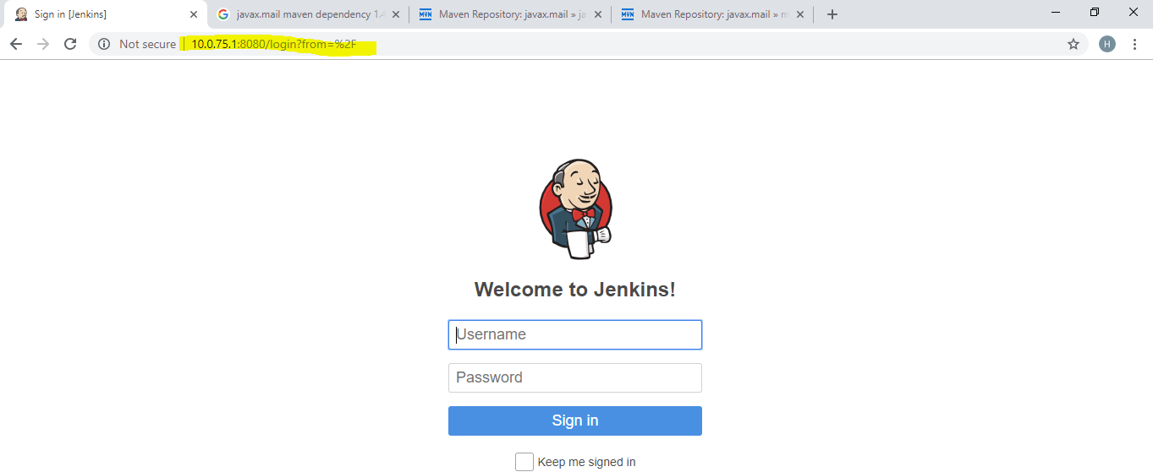

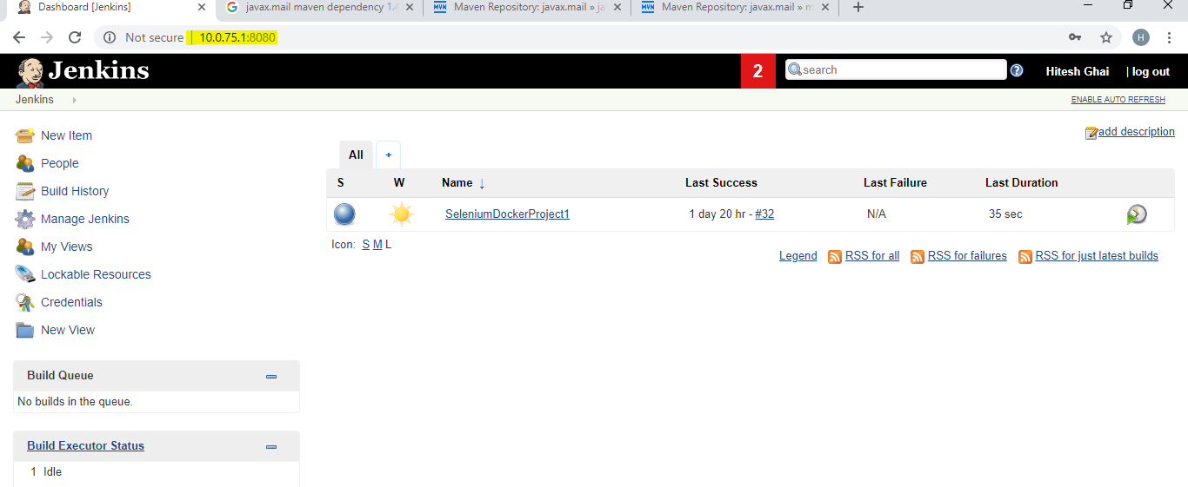

Step 4: Click on job name and then click on ‘Extent Report’ link.

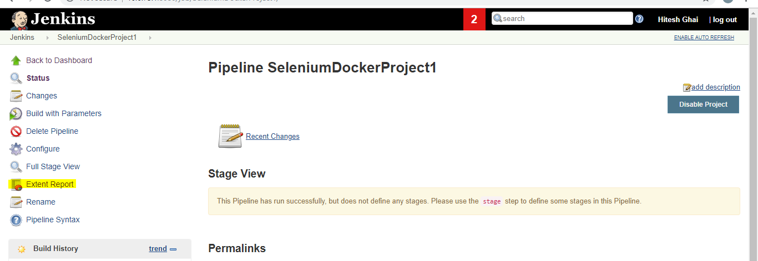

And now pick or copy the highlighted url text

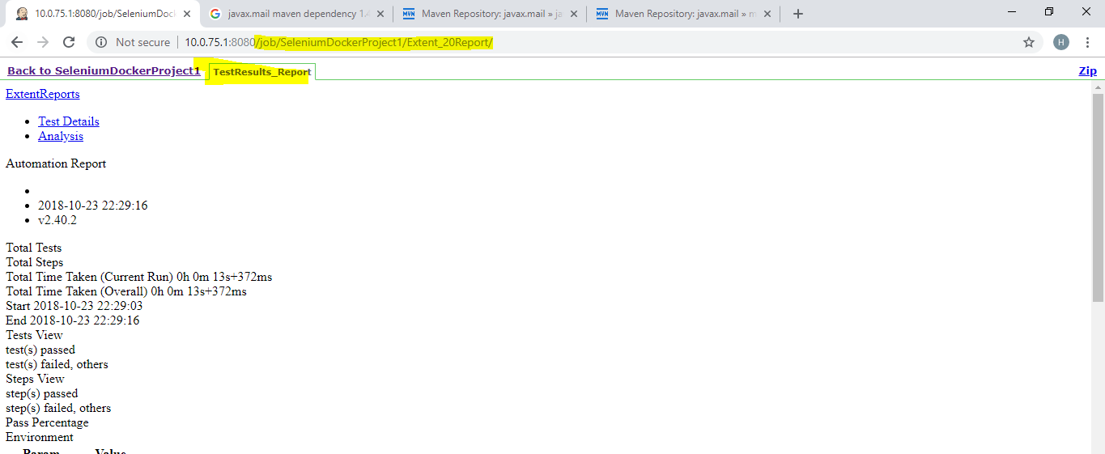

Step 5: In eclipse, copy that highlighted url as below in order to get the full url of extent report

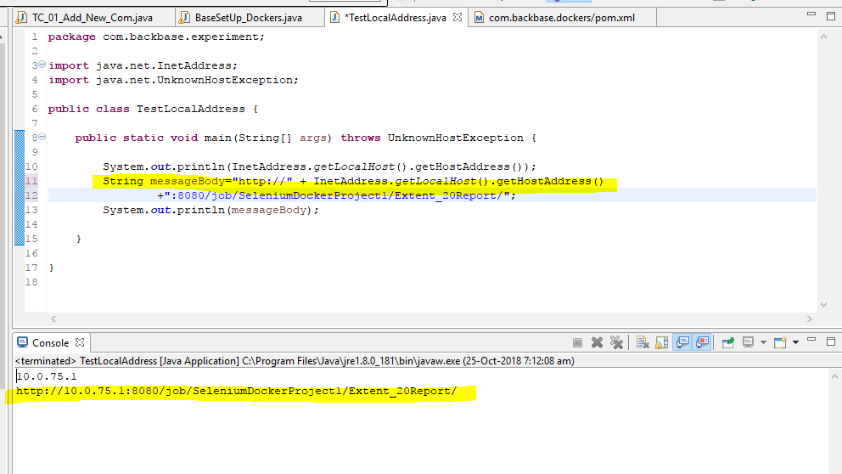

Full code

Note: In case following exception occurs then visit this site and on the security option

javax.mail.AuthenticationFailedException:

<https://myaccount.google.com/lesssecureapps?pli=1>

